

**SHAID SMARAK COLLEGE**

Kirtipur, Kathmandu

*Assignment No. 3 of Digital logic*

***Submitted by :-***

*Amir maharjan*

*BCA 2nd  Semester*

***Submitted to :-***

*Himal Raj Gentil*

# C programming

Assignment 2

Q.1. Print the absolute value of input number using if control statement.

Program.

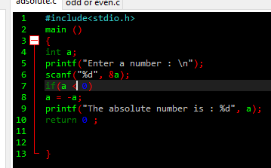

Output.

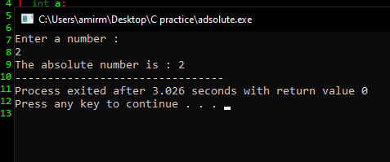

Q.2 Print whether the entered number is odd or even using if… else function.

Program.

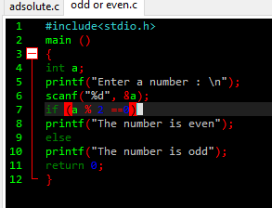

Output.

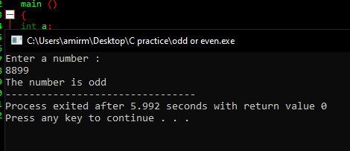

Q.3 Check whether the input number lies in between certain range using && compound relations.

Program.

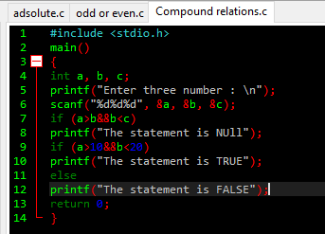

Output.

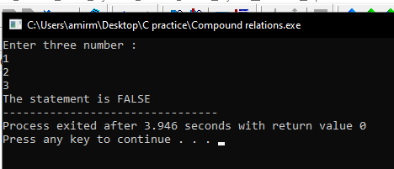

Q.4 Check whether the input payment method is eligible to make payment or not.

Program.

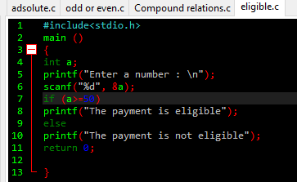

Output.

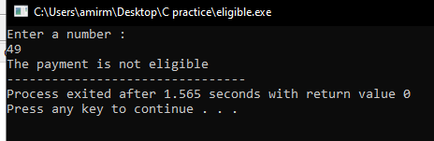

Q.5 Write a program to check whether the input year is leap year or not.

Program.

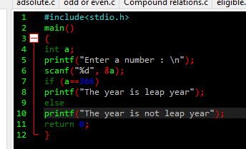

Output.

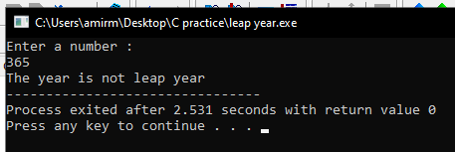

***The end***